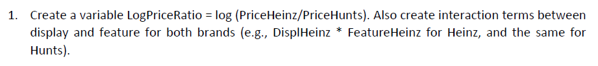

Code:

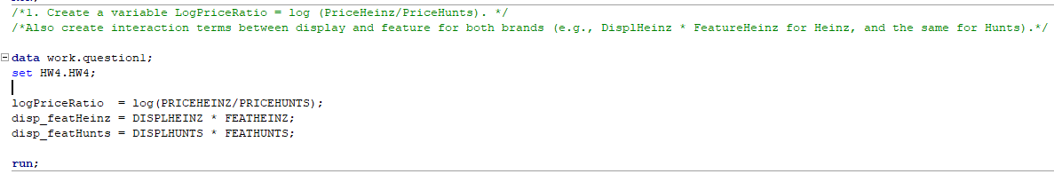

Output:

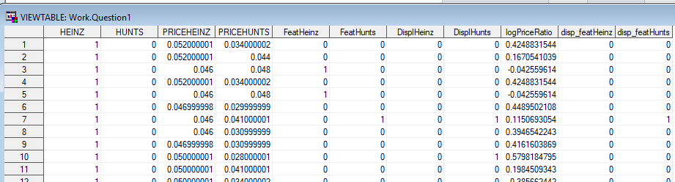



Code:

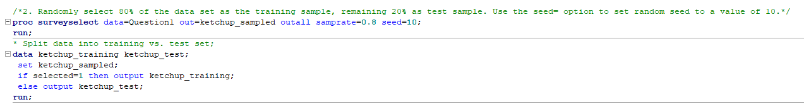

Output:

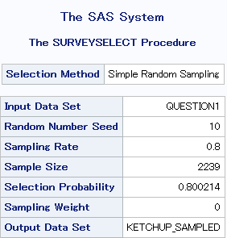

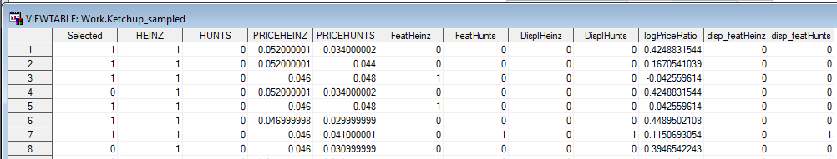

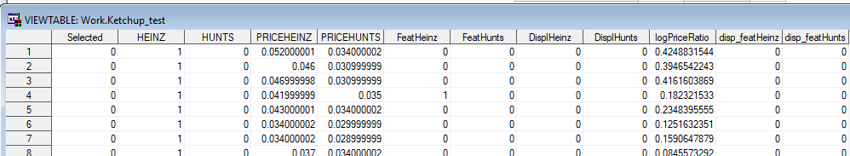

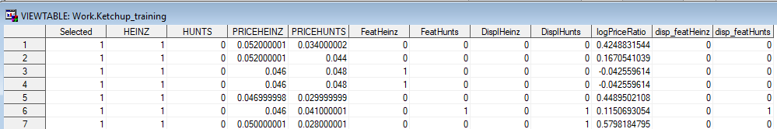

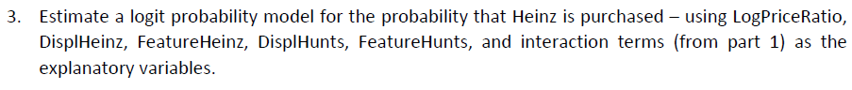

Code:



Output:

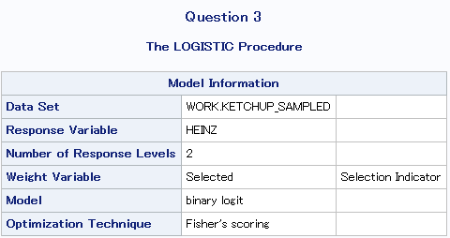

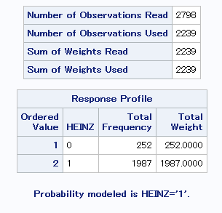



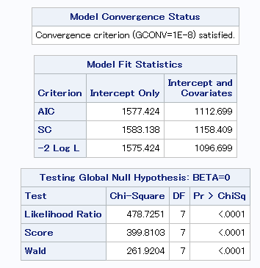

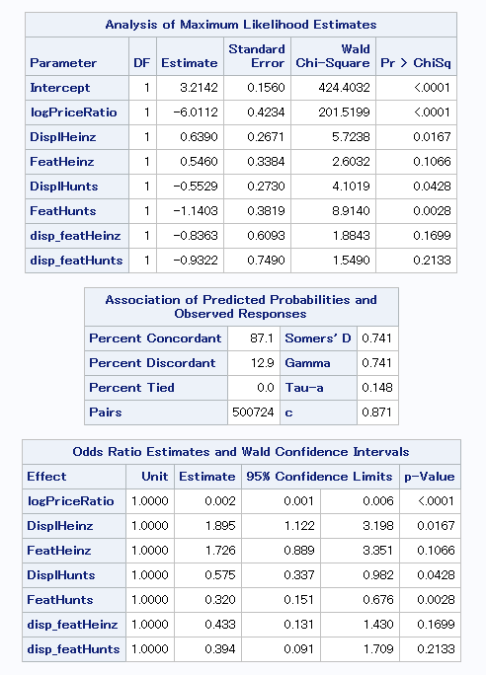

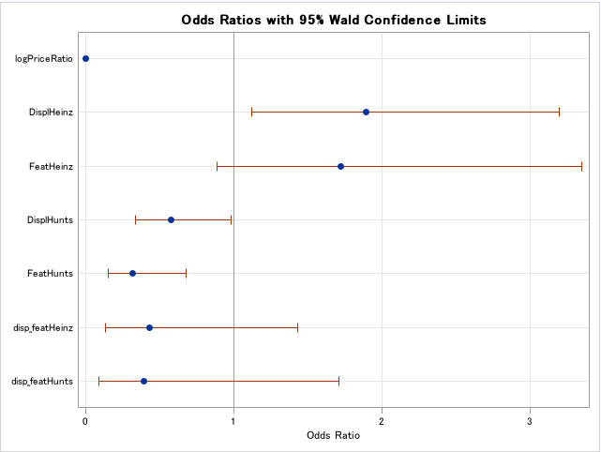

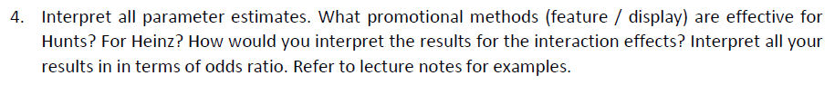

|  |  |  |
| --- | --- | --- |
| **Analysis of Maximum Likelihood Estimates** | | |
| **Parameter** | **Estimate** | **Interpretation** |
| Intercept | 3.2142 | Without any variables into account, Probability of customer buying Heinz is 3.21 |
| logPriceRatio | -6.0112 | 1 unit increase in logPriceRatio decreases the probability of customer buying Heinz is 6.01 |
| DisplHeinz | 0.639 | 1 unit increase in Display of Heinz on shelf increase Probability of buying Heinz by 0.639 units |
| FeatHeinz | 0.546 | 1 unit increase in Featuring Heinz increases Probability of buying Heinz by 0.546 units |
| DisplHunts | -0.5529 | 1 unit increase in Display of Hunts on shelf decreases Probability of buying Heinz by 0.5529 units |
| FeatHunts | -1.1403 | 1 unit increase in Featuring Hunts decreases Probability of buying Heinz by 1.14 units |
| disp_featHeinz | -0.8363 | 1 unit increase in disp_featHeinz decreases the Probability of customer buying Heinz by 0.84. **P-value here is statistically insignificant, so we can say there is no interaction between Display and Featuring of Heinz** |
| disp_featHunts | -0.9322 | 1 unit increase in disp_featHunts decreases the probability of customer buying Heinz is 0.93. **P-value here is statistically insignificant, so we can say there is no interaction between Display and Featuring of Hunts** |

|  |  |  |
| --- | --- | --- |
| **Odds Ratio Estimates and Wald Confidence Intervals** | | |
| **Parameter** | **Estimate** | **Interpretation** |
| logPriceRatio | 0.002 | 1 unit increase in logPriceRatio increases the odds of customer buying Heinz is 0.002 |
| DisplHeinz | 1.895 | 1 unit increase in DisplHeinz increases the Odds of customer buying Heinz is exp(1.895) = 6.65 |
| FeatHeinz | 1.726 | 1 unit increase in FeatHeinz increases the Odds of customer buying Heinz is exp(1.726) = 5.61 |
| DisplHunts | 0.575 | 1 unit increase in DisplHunts increases the odds of customer buying Heinz exp(0.575) = 1.77 |
| FeatHunts | 0.32 | 1 unit increase in FeatHunts increases the odds of customer buying Heinz is exp(0.32) = 1.37 |
| disp_featHeinz | 0.433 | 1 unit increase in displ_featHeinz increases the odds of customer buying Heinz is exp(0.433) = 1.54 |
| disp_featHunts | 0.394 | 1 unit increase in disp_feathunts increases the odds of customer buying Heinz is exp(0.394) = 1.48 |

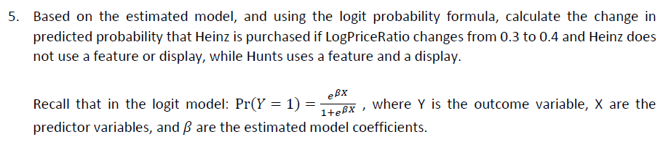

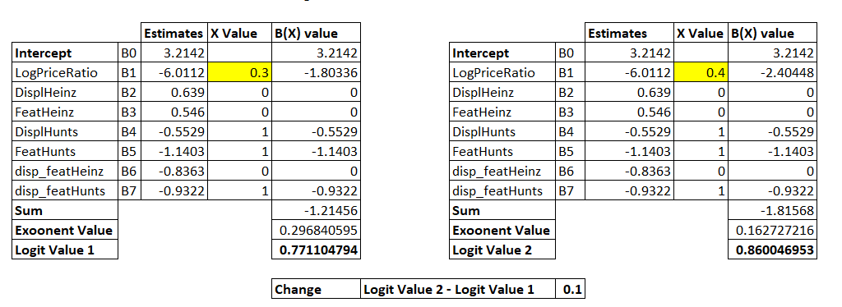



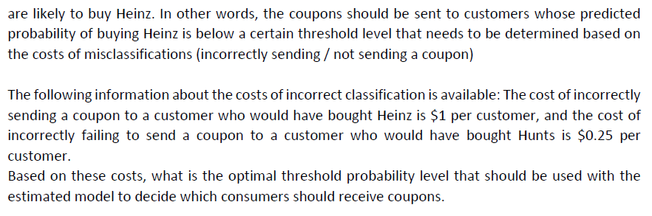

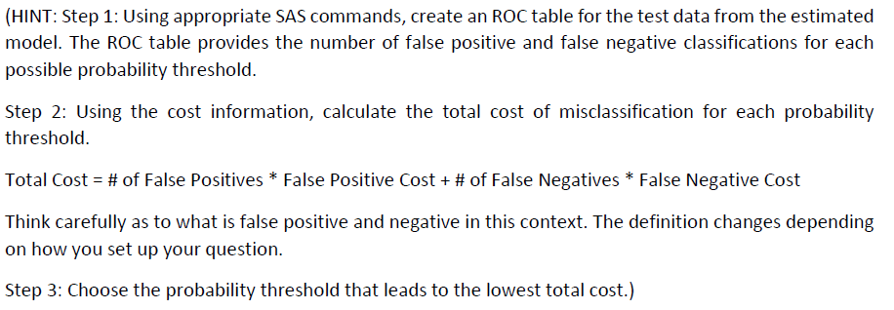

Ans:

**Creating ROC Table**

Code:

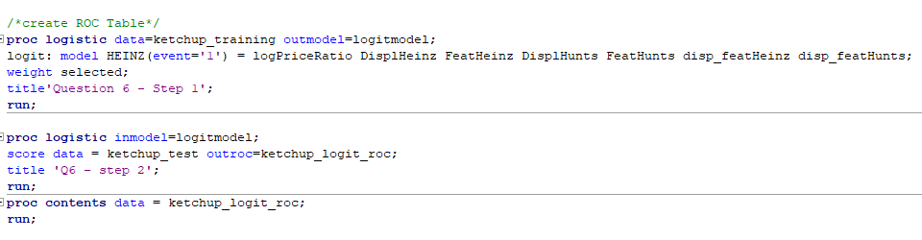

Output:

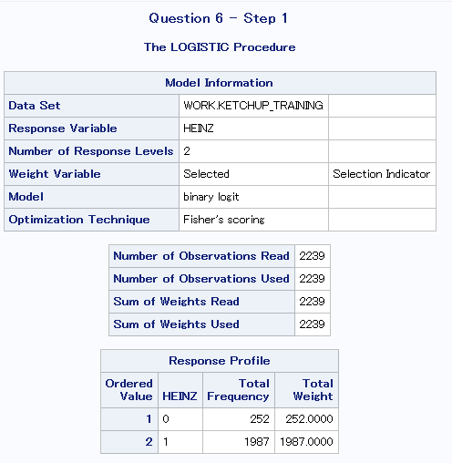

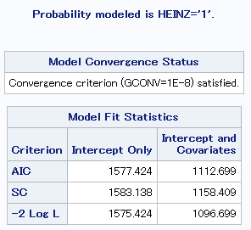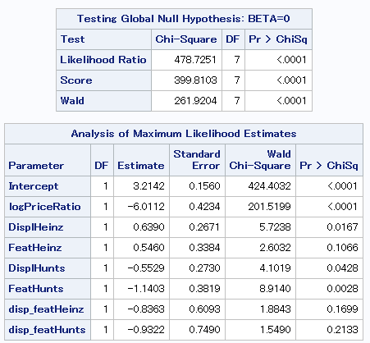

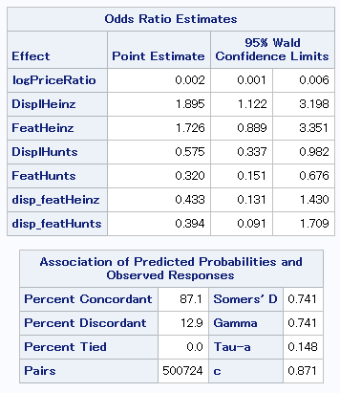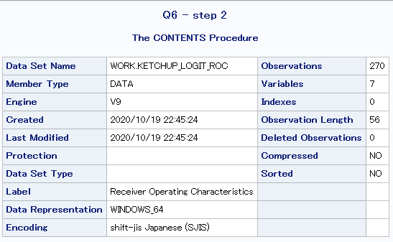

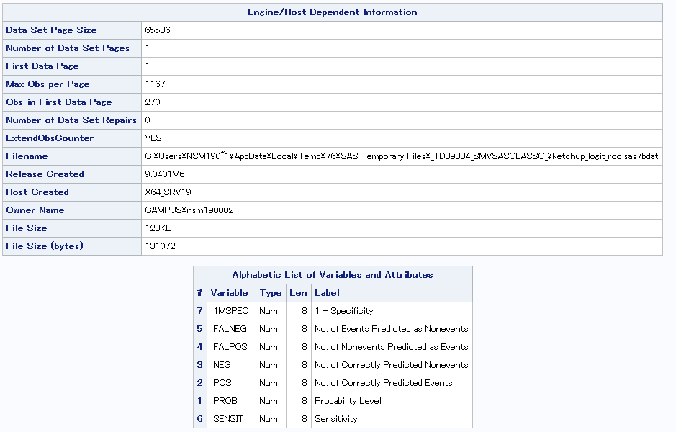

**Export ROC Table program:**

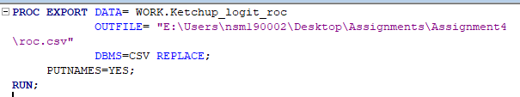

Total Cost = # of False Positives * False Positive Cost + # of False Negatives * False Negative Cost



Applying the above formula in roc table received from SAS.

And then finally sort the TOTAL_COST Column and select the least cost.

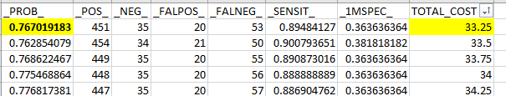

Final Probability Threshold: **0.77**